## Mapo Tofu

1. Chinese
2. Source: Own recipe
3. Category: Main Dish
4. 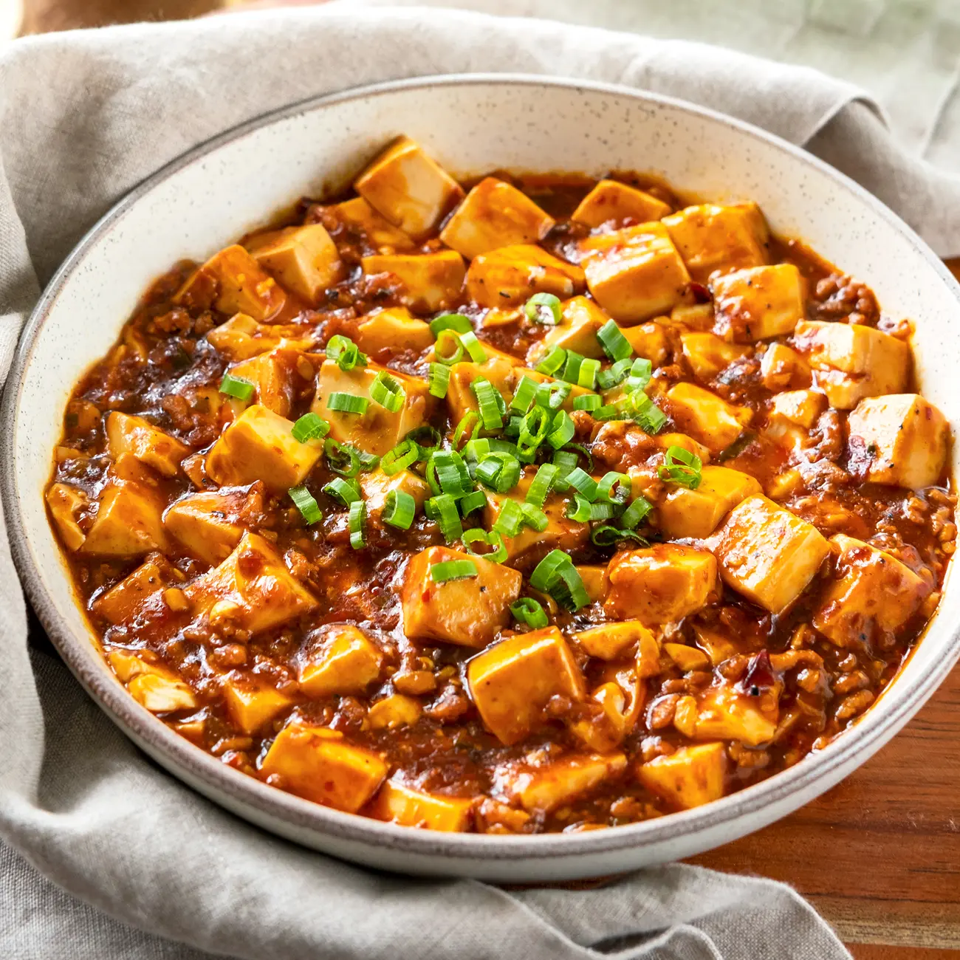
5. mapo_tofu.jpeg
6. Need something smooth and spicy? Mapo Tofu is a simple tofu dish from Sichuan China. It's great over rice and easy to prep/save for college students! This recipe is for people who want to try authentic Chinese food but do not have Sichuan spices to use.
7. Ingredients:
8. 1 pack silken tofu
9. 2 green onions, thinly sliced
10. 1/2 lb ground pork
11. 1 pack mapo tofu sauce (store bought)
12. 3 cloves minced garlic
13. soy sauce to taste
14. 2 tbsp cooking oil

9. Steps:

1. Brown pork in wok with oil for 4-5 minutes
2. Add sauce and garlic, stir fry for 2 minutes
3. Add tofu and mix lightly as to not break up the tofu too much, until heated through
4. Add soy sauce, green onion and dish up

10. Additional photos of recipe

11. Ground_pork.jpeg

12. Browning ground pork in wok

13. Add_tofu.jpeg

14. Adding tofu and sauce to the wok

15. **Karen Koo and Patrick Zhu**